MACHINE LEARNING · WEEK 3 · LABORATORY
Lab 3: Logistic Regression, Softmax and Naive Bayes from Scratch
Sigmoid and log loss · gradient descent for classification · confusion matrices and thresholds · softmax regression · Gaussian and multinomial Naive Bayes

Item | Details
Programme | BSc in Artificial Intelligence — Central Asian University, Fall Semester 2026–2027
Syllabus | Week 3 lab: logistic regression and maximum likelihood, multiclass classification, Naive Bayes
Duration | ≈ 3.5 hours in the lab; finish at home if needed
Files | ML_Week3_Lab3_Classification_Starter.ipynb (you work in this notebook)
Data | Palmer penguins (seaborn-data on GitHub) · Wisconsin breast cancer (built into scikit-learn) · SMS Spam Collection (5,572 messages)
Submission | Lab03_<Surname>_<Name>.ipynb, run top to bottom, by the deadline announced in class

1. Learning outcomes
After this lab you will be able to:
- implement the sigmoid in a numerically stable way, the log loss, and the gradient of logistic regression — and verify the gradient numerically;
- train logistic regression with gradient descent from scratch and reproduce scikit-learn's result;
- use predicted probabilities: build a confusion matrix, compute precision and recall, choose a decision threshold from costs, and read coefficients as odds ratios;
- implement softmax regression for three classes with the cross-entropy loss;
- implement Gaussian and multinomial Naive Bayes from scratch, explain Laplace smoothing, and build a working SMS spam filter.

2. Before you start
- Open Google Colab (colab.research.google.com) → File → Upload notebook → choose the starter notebook. Or open it in Jupyter on your own computer (Python 3.10+, NumPy, pandas, matplotlib, scikit-learn).
- The notebook downloads the penguin and SMS data from GitHub — you need internet access. The breast-cancer data come with scikit-learn.
- Read the cell “How to use this notebook”. Every code cell has a text cell above it with: What this cell does, Your task, Hint, Expected result.
- Run the cells in order. When a CHECK cell prints ✓, move on. If it stops with an AssertionError, read its message — it tells you what is wrong.
Label in the notebook | Meaning
# TODO | Code you must complete — replace None, pass or the placeholder line.
# CHECK … — do not edit | Automatic test: prints ✓ when your work is correct. 13 CHECK cells in total.
Your answer (…) | A text cell for a 2–5 sentence explanation in your own words.
Expected result | What you should see. Differences in the last digit are fine.

3. Overview and marks
Part | Topic | Time | Marks
A | Sigmoid, stable sigmoid, log loss, gradient check | 30 min | 15
B | Logistic regression from scratch (penguins) | 45 min | 20
C | Breast cancer: confusion matrix, threshold, odds ratios | 35 min | 20
D | Softmax regression for three species | 40 min | 20
E | Gaussian Naive Bayes and an SMS spam filter | 50 min | 20
F | Reflection questions; notebook quality | 10 min | 5
 | Total | ≈ 3.5 h | 100

Part A — The sigmoid, the log loss and the gradient
WHAT YOU NEED TO KNOW
Logistic regression turns a linear score into a probability with the sigmoid, measures quality with the log loss, and is trained with the gradient of that loss. All three come from Lecture 3, Parts 02–03.

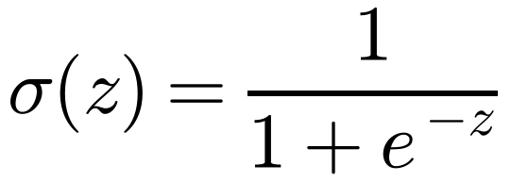
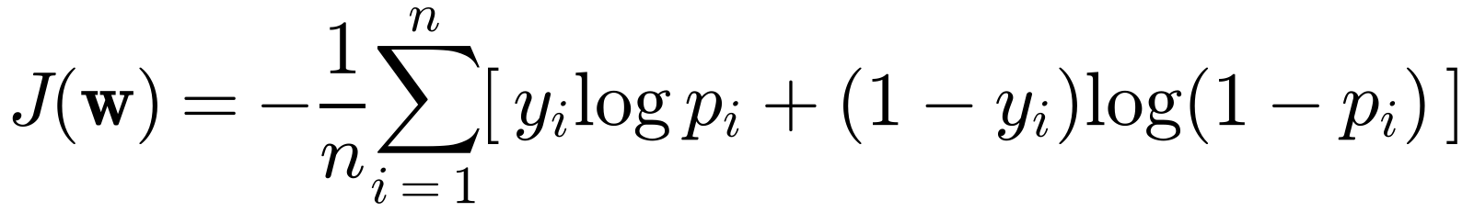
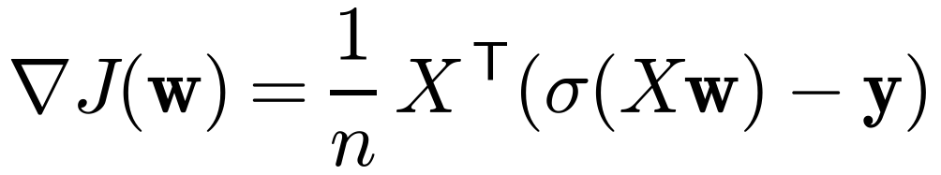

Tasks
Task | What you do | Expected result
A1 | Write sigmoid(z) with np.exp. | σ(−2), σ(0), σ(2) = 0.1192, 0.5, 0.8808
A2 | Write stable_sigmoid(z): clip z to [−500, 500] first. It replaces sigmoid. | σ(−1000), σ(0), σ(1000) = 0, 0.5, 1 with no warning
A3 | Write log_loss_np(y, p). | 0.272 on the five examples; matches scikit-learn
A4 | Write gradient(w, A, y); compare with a numerical gradient (central differences). | difference < 10⁻⁸
Questions: A3 — which example costs most and what is the loss of always predicting 0.5? A4 — what is the gradient contribution of an example that is predicted perfectly, and of one that is badly wrong?
My answer: A3: The example with the most confident wrong prediction costs the most. If we always predict 0.5, the log loss is about 0.693 (log 2). A4: A perfect prediction contributes almost zero to the gradient. A badly wrong prediction gives a larger gradient and changes the weights more.

Part B — Logistic regression from scratch on the penguins
WHAT YOU NEED TO KNOW
Task: Adelie (y = 0) or Chinstrap (y = 1) from bill length and depth. 219 penguins, split 75 % / 25 % with random_state = 0. Features are standardised with the training mean and standard deviation, and a column of ones is added for the bias.
A small L2 penalty λ = 1/n (not on the bias) makes your model identical to scikit-learn's default LogisticRegression(C = 1).

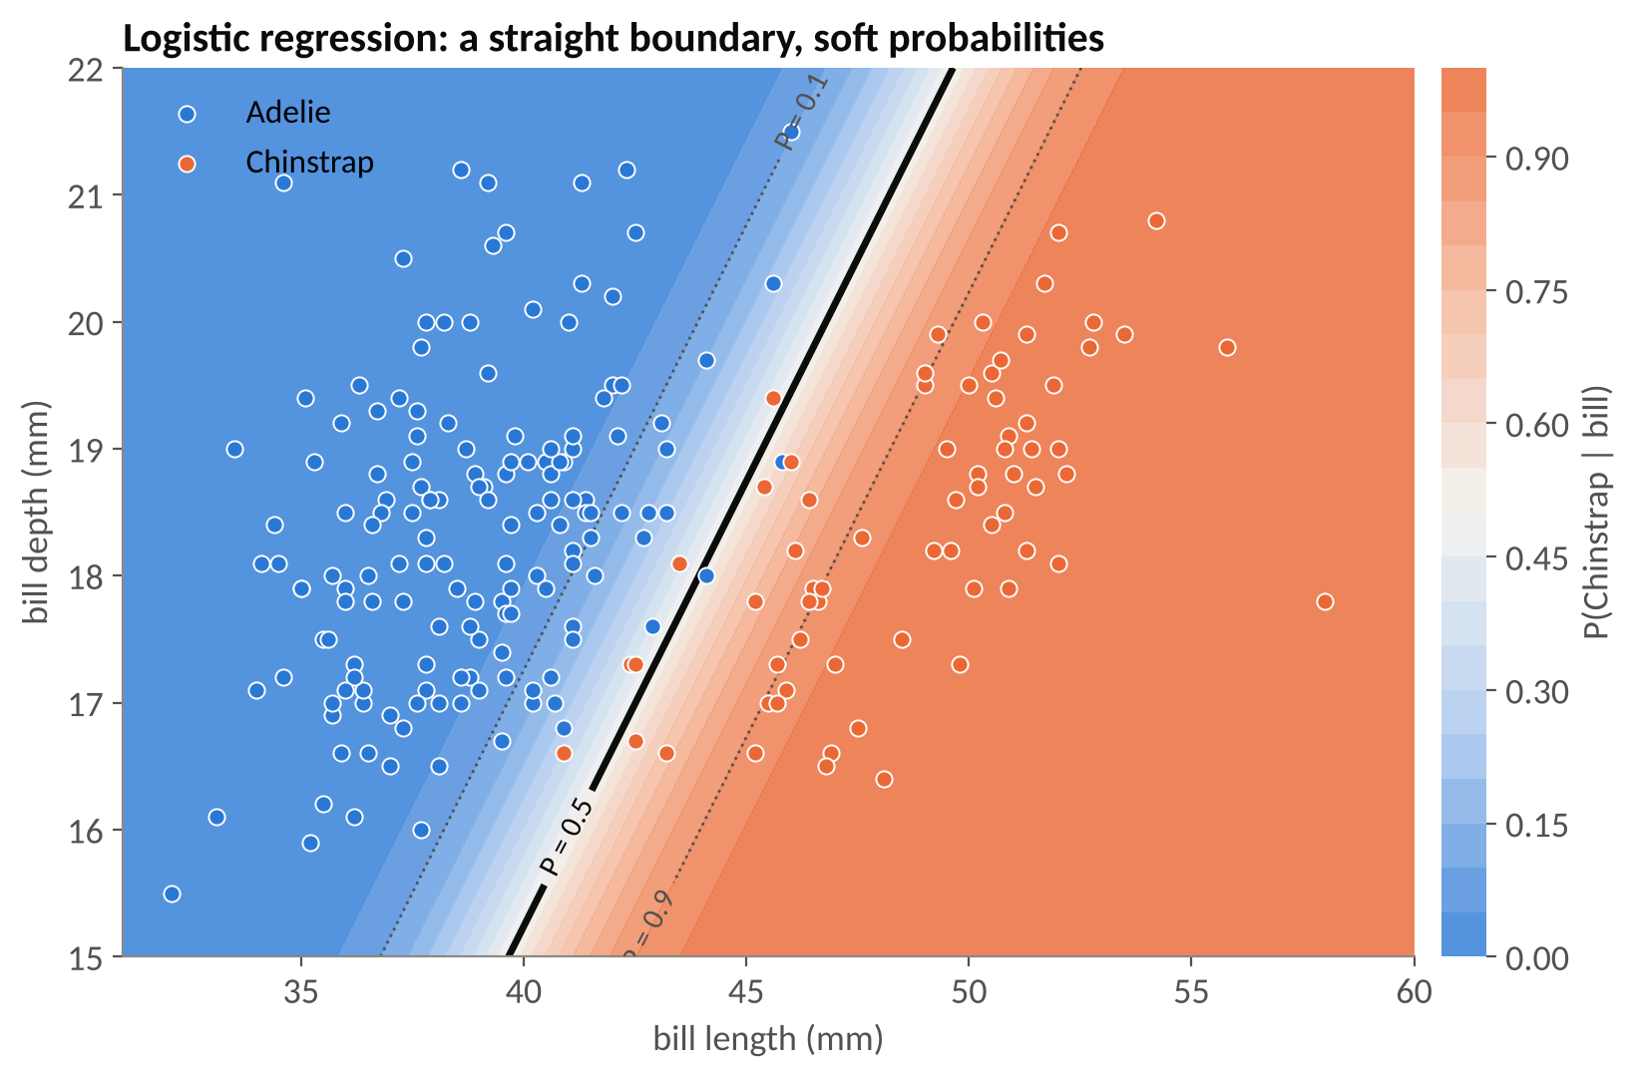
The model you will build: a straight decision boundary with soft probabilities (all 219 birds shown).
Task | What you do | Expected result
B0 | Run the data preparation. | A_train (164, 3), A_test (55, 3); 31.1 % Chinstrap
B1 | Complete the gradient-descent loop of fit_logistic (η = 0.5, 2000 steps, λ = 1/n). | w ≈ (−1.848, 3.842, −1.177); loss 0.0865; matches scikit-learn
B2 | Write predict(w, A, t) and compute accuracies. | training 0.970, test 0.964
B3 | Complete the boundary formula s₂ = −(w₀ + w₁s₁)/w₂ and plot. | loss curve from 0.693; straight boundary
B4 | Run three learning rates (300 steps). | 0.1782, 0.0893, 0.0865
B5 | Run the separable Adelie-vs-Gentoo experiment. | largest |w| 2.9, 8.7, 24.4, 43.3 as C grows
Questions: B4 — why does logistic regression tolerate much larger learning rates than linear regression? B5 — why do the weights grow without limit on separable data, and which setting prevents it?
My answer: B4: The logistic loss has bounded curvature, so gradient descent can use larger learning rates on these scaled features. B5: On separable data, bigger weights make the probabilities closer to 0 and 1, and the loss keeps decreasing. L2 regularization prevents the weights from growing too large.

Part C — Breast cancer: probabilities, thresholds and odds ratios
WHAT YOU NEED TO KNOW
569 biopsies, 30 measurements of cell nuclei; we code malignant = 1. You may use a scikit-learn pipeline for the model, but you write the evaluation yourself.
Confusion matrix: rows = truth, columns = prediction: [[TN, FP], [FN, TP]]. Recall = TP/(TP + FN); precision = TP/(TP + FP). Cost-based threshold: t* = C_FP/(C_FP + C_FN). Odds ratio of a standardised feature: e^w per standard deviation.

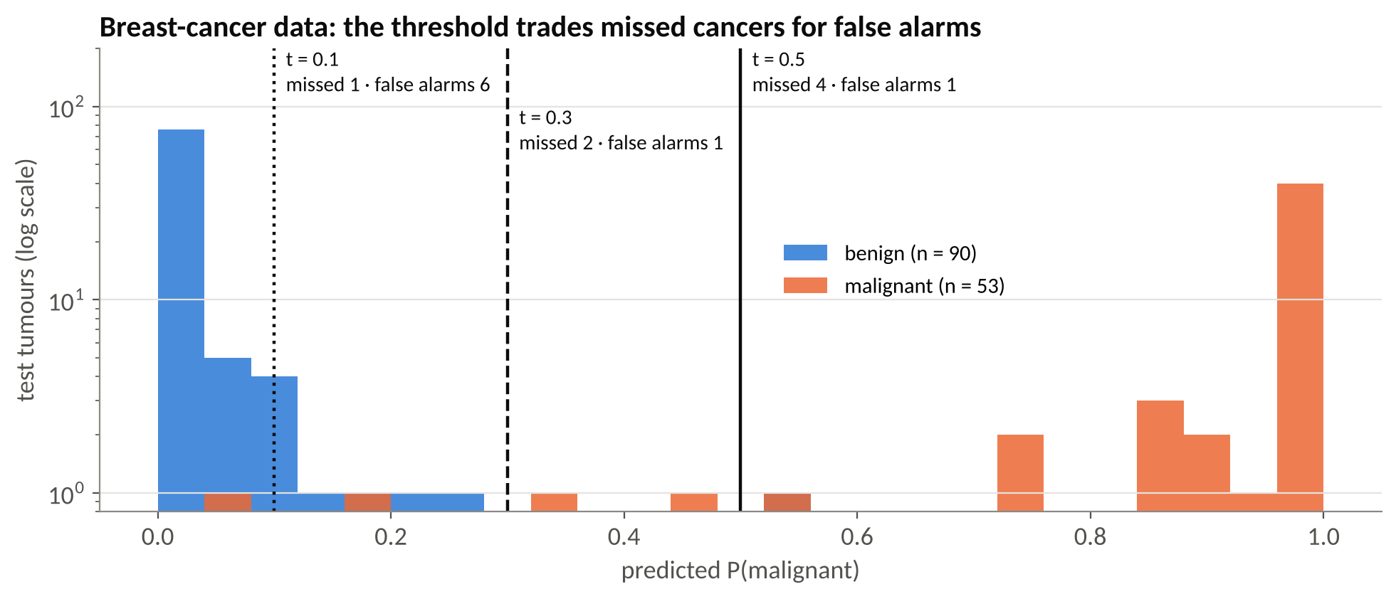
Predicted probabilities on the test set and three thresholds.
Task | What you do | Expected result
C0 | Load and split (random_state = 42). | training (426, 30), test (143, 30); 53 malignant in test
C1 | Pipeline StandardScaler → LogisticRegression; probabilities p_bc. | test accuracy 0.965
C2 | Write confusion_2x2 from scratch. | [[89, 1], [4, 49]]
C3 | Write recall_precision. | recall 0.925, precision 0.980
C4 | Loop over t = 0.5, 0.3, 0.1. | missed 4 / 2 / 1; false alarms 1 / 1 / 6
C5 | Top-5 coefficients and their odds ratios. | worst texture ×3.92, radius error ×3.55, worst symmetry ×2.82, …
Questions: C4 — which threshold if a missed cancer is 20 times worse than a false alarm, and why choose it on validation data? C5 — why is a negative coefficient for “compactness error” not evidence that compact nuclei are protective?
My answer: C4: The cost-based threshold is 1/(1+20), or about 0.048, so I would use around 0.05. I would choose it on validation data to avoid using the test results to tune the model. C5: This coefficient shows a relationship after considering the other features. It does not prove that compact nuclei prevent cancer.

Part D — Softmax regression for three species
WHAT YOU NEED TO KNOW
Weights W have one column per class. P = softmax(AW); loss = cross-entropy; gradient (1/n) Aᵀ(P − Y) + λW (no penalty on the bias row). Labels are one-hot rows of the identity matrix: np.eye(3)[y].
Stable softmax: subtract each row's maximum before exponentiating — use keepdims=True.

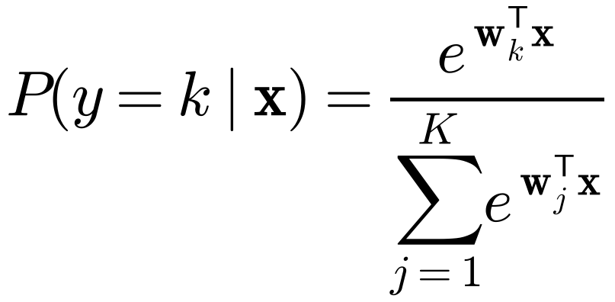
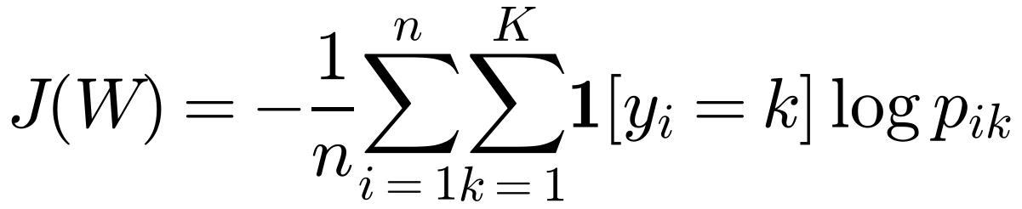
Task | What you do | Expected result
D0 | Build the one-hot matrix Y_train. | A3_train (256, 3), Y_train (256, 3), counts 113 / 51 / 92
D1 | Write a stable softmax(Z). | [0.659, 0.2424, 0.0986]; no overflow for scores ≈ 1000
D2 | Write cross_entropy(Y, P). | log 3 = 1.0986 for uniform predictions
D3 | Complete fit_softmax (η = 0.5, 3000 steps, λ = 1/n). | loss 0.1207; probabilities within 0.01 of scikit-learn
D4 | Accuracy, confusion matrix, new penguin (45, 17). | accuracy 0.954; (0.162, 0.549, 0.289) → Chinstrap
D5 | Plot the decision regions. | three regions with straight boundaries
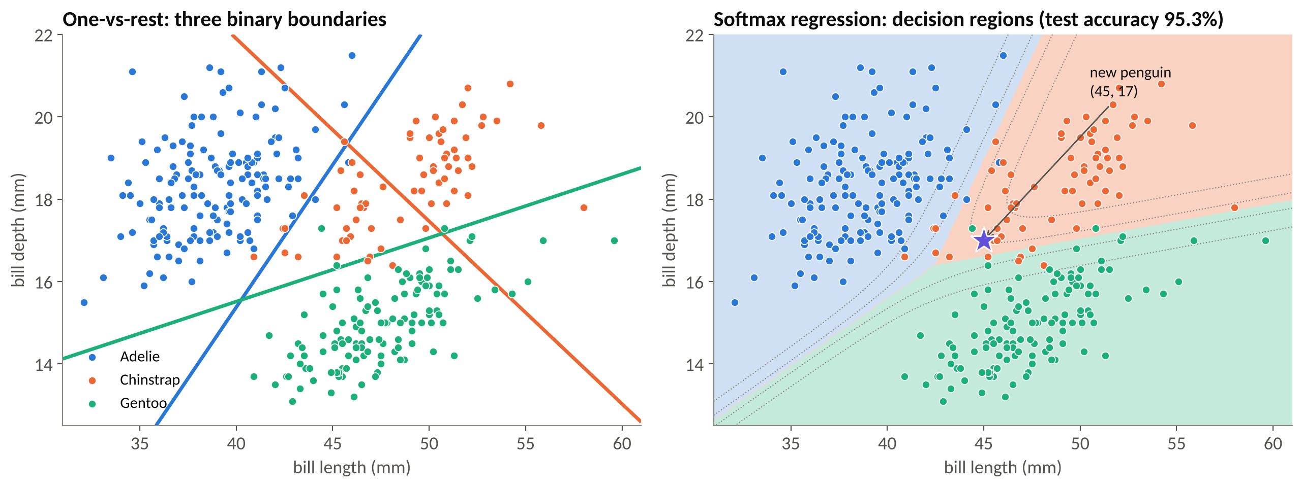
One-vs-rest boundaries (left) and the softmax regions you will reproduce (right).
Question D: why do all test errors involve Chinstrap, and why is its recall the lowest?
My answer: Chinstrap has measurements that overlap with both other species. Because of this, the model sometimes predicts Adelie or Gentoo instead. More Chinstrap birds are missed, so its recall is lower.

Part E — Naive Bayes: Gaussian and a spam filter from scratch
WHAT YOU NEED TO KNOW
Naive Bayes is generative: estimate P(y) and P(x_j | y) for each class, assume the features are independent given the class, and predict the class with the largest log prior plus sum of log-likelihoods. Training is counting and averaging — no gradient descent.
Gaussian NB: one mean and variance per class and feature. Multinomial NB for text: word probabilities from counts, with Laplace smoothing α.

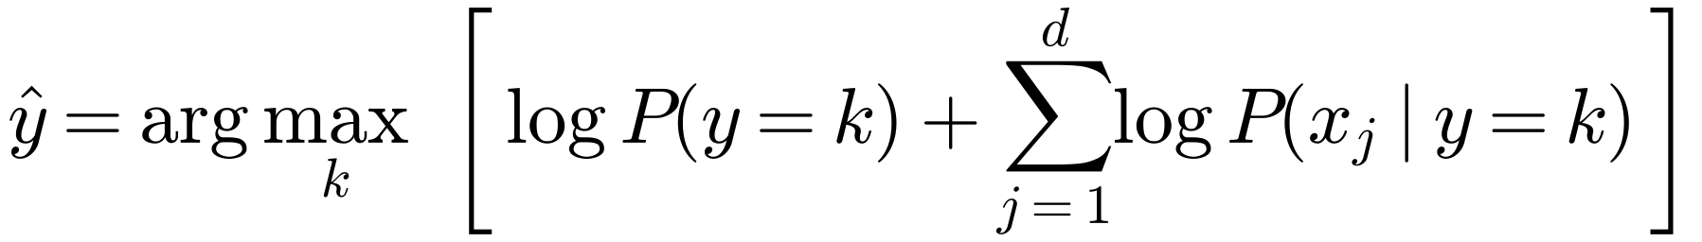
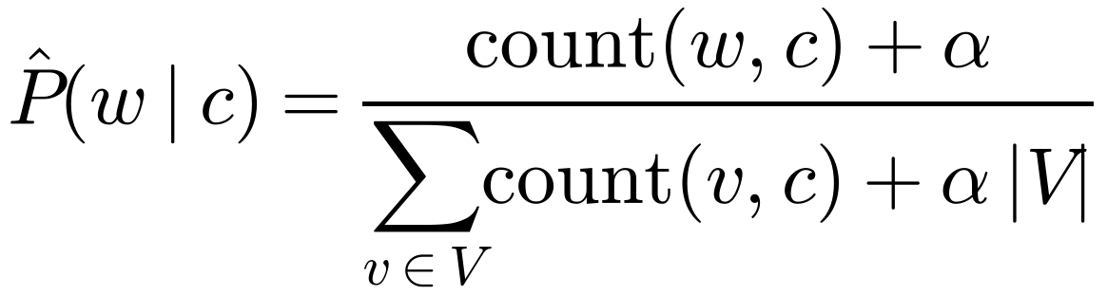
Task | What you do | Expected result
E1 | Gaussian NB from scratch on the penguins (raw mm). | priors 0.441 / 0.199 / 0.359; test accuracy 0.93; same predictions as scikit-learn
E2 | Load the SMS data; bag of words with CountVectorizer (fit on training only). | C_train (4179, 7387); spam fraction 0.134
E3 | Write mnb_fit (log prior, smoothed log word probabilities). | log prior (−0.1439, −2.0099); equal to MultinomialNB
E4 | Score in log space with one matrix product; predict. | accuracy 0.9864; [[1204, 2], [17, 170]]
E5 | Zero-count demo: “Did you claim it? Call me when you get home”, α = 0 vs 1; then five α values. | P(spam) = 1.0 (α = 0) vs 0.0001 (α = 1)
E6 | Ten most spam-indicative words. | claim, prize, 150p, tone, guaranteed, 500, cs, 18, 1000, awarded
E7 | Compare with logistic regression and the baseline. | 0.9785 and 0.8658
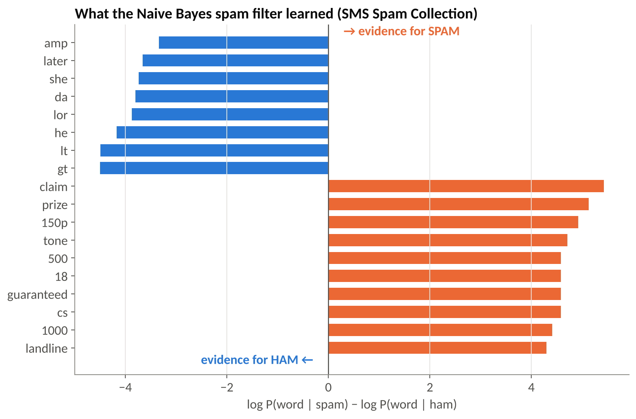
What a Naive Bayes spam filter learns. Note the artefacts lt, gt and amp (HTML fragments).
Questions: E1 — is conditional independence plausible for bill length and depth? E5 — why is the unsmoothed model 100 % sure, and why may we not choose α on the test set? E7 — which mistakes matter more for a phone company, and which model would you deploy?
My answer: E1: Not completely. Bill length and depth may be related even for penguins of the same species. E5: Without smoothing, a word with zero count gives zero likelihood, making the prediction too certain. We must choose alpha using validation data, not the test set. E7: Blocking a real message as spam can be very harmful, so false positives matter a lot. I would prefer Multinomial Naive Bayes here because it has higher test accuracy, but I would also check its false-positive rate before deployment.

Part F — Reflection
- Where does the common gradient form (1/n) Aᵀ(prediction − truth) come from? Which Week 2 loss had the same form?
My answer: It comes from differentiating the loss with respect to the weights using the chain rule. The squared-error loss for linear regression in Week 2 had the same prediction-minus-truth form.
- Why did logistic regression need gradient descent while Naive Bayes was trained by counting? Use the words discriminative and generative.
My answer: Logistic regression is a discriminative model: it learns the boundary between classes by minimizing loss with gradient descent. Naive Bayes is a generative model: it estimates class and feature probabilities directly from counts or means.
- Give an example from the lab where the 0.5 threshold is a poor choice, and how you would choose a better one.
My answer: In the breast-cancer example, using 0.5 can miss some malignant cases. If missing cancer costs much more, I would use a lower threshold, around 0.05, and evaluate it on validation data.
- Which part was hardest for you, and what helped?
My answer: The hardest part for me was understanding the gradients and the softmax calculations. Checking the array shapes, reading the hints, and comparing the results with scikit-learn helped me.

4. Troubleshooting — the ten most common problems
Symptom | Likely cause and fix
TypeError: unsupported operand … NoneType | A function still returns None. Complete the TODO in the cell named in the error, then rerun the cells below it.
RuntimeWarning: overflow encountered in exp | Expected in A2 for the old sigmoid. Later it means you are not using stable_sigmoid — rerun A2.
ValueError: matmul: … mismatch | Shape error. Print A.shape, w.shape. For one example in D4, use x_new[None, :] to make it a 1 × 3 matrix.
CHECK B1 fails, weights ≈ 0 | The update line still reads w = w. Use w = w - eta * g.
CHECK B1 fails, weights close but not equal | Penalty applied to the bias, or wrong λ. Use lam * np.r_[0, w[1:]] and lam = 1 / n_train.
Softmax gives nan | You did not subtract the row maximum, or used keepdims=False.
Softmax rows don't sum to 1 | Divided by the sum of the whole matrix instead of each row: use axis=1, keepdims=True.
E3 CHECK fails slightly | Smoothing denominator must be counts.sum(axis=1, keepdims=True) + alpha * C.shape[1] (α times the vocabulary size).
Download fails (penguins or SMS) | No internet access. Ask the assistant for the CSV/TSV file, upload it to Colab and replace the URL by the file name.
Results differ in the 3rd decimal | Different library versions — fine. Large differences mean a bug: compare with the expected result in the cell's text.

5. Submission checklist
- Restart and run all — no errors.
- All 13 CHECK cells print ✓ (A1–A4, B1, C1, C2, D1–D3, E1, E3, E4).
- Plots B3 and D5 visible.
- All written answers completed (A3, A4, B4, B5, C4, C5, D, E1, E5, E7, F1–F4).
- File named Lab03_<Surname>_<Name>.ipynb and uploaded.

6. Marking rubric
Part | Points | Full marks when
A | 15 | A1–A4 CHECKs pass; answers mention log 2 and the zero contribution of perfect predictions
B | 20 | B1 CHECK passes; accuracies and boundary correct; B4/B5 answers explain bounded curvature and infinite MLE weights
C | 20 | C1, C2 CHECKs pass; recall/precision and threshold table correct; odds ratios; C4/C5 answers (t ≈ 0.05, validation data, conditional coefficients)
D | 20 | D1–D3 CHECKs pass; accuracy, confusion matrix and new-penguin probabilities; answer D
E | 20 | E1, E3, E4 CHECKs pass; zero-count demo and spam words; answers E1, E5, E7
F | 5 | Thoughtful reflections; clean notebook that runs top to bottom

7. Optional extensions (no marks, for the curious)
- Add bigrams to the spam filter: CountVectorizer(ngram_range=(1, 2)). Does accuracy improve? What happens to the vocabulary size?
- Choose α and the decision threshold of the spam filter with 5-fold cross-validation on the training set (GridSearchCV), then evaluate once on the test set.
- Replace gradient descent in Part B with Newton's method: w ← w − H⁻¹∇J, with H = (1/n) Aᵀ diag(p(1 − p)) A. How many steps does it need?
- Fit Gaussian Naive Bayes with all four penguin measurements and compare it with softmax regression on the same features.

References
- Lecture 3 slides and speaker script (Week 3).
- James et al. (2023), An Introduction to Statistical Learning with Python, Ch. 4.
- Jurafsky & Martin, Speech and Language Processing (3rd ed. draft): Naive Bayes and logistic regression chapters.
- Almeida, Gómez Hidalgo & Yamakami (2011), SMS Spam Collection. · Street, Wolberg & Mangasarian (1993), breast-cancer data. · Gorman, Williams & Fraser (2014), Palmer penguins.

